Referentielle Integritätsbedingungen

In der Benutzerverwaltung der Applikation „WISSLearncards“

# Tabelle

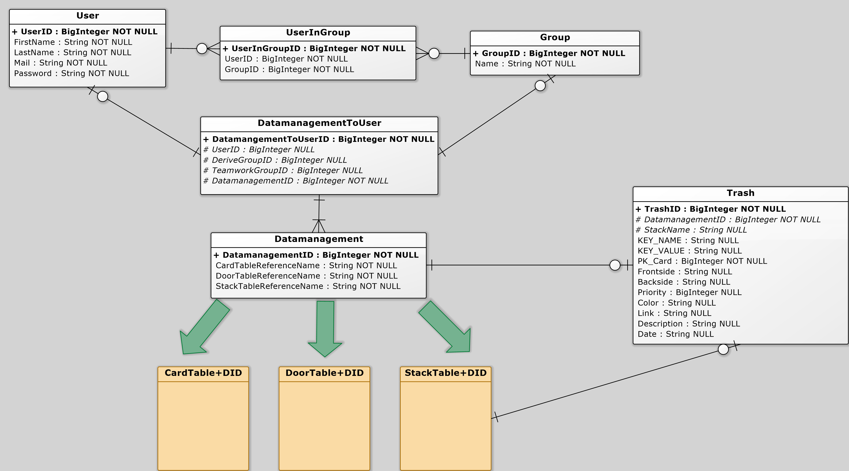

|  |  |  |
| --- | --- | --- |
| Tabelle A | Beziehung | Tabelle B |
| User | ON DELETE CASCADE  ON UPDATE CASCADE | UserInGroup |
| Group | ON DELETE CASCADE  ON UPDATE CASCADE | UserInGroup |
| User | ON DELETE SET NULL  ON UPDATE CASCADE | DatamanagementToUser |
| Group | ON DELETE SET NULL  ON UPDATE CASCADE | DatamanagementToUser |
| Datamanagement | ON DELETE CASACDE  ON UPDATE CASCADE | DatamanagementToUser |
| Trash | ON DELETE CASCADE  ON UPDATE CASCADE | Datamanagement |